Aria Integration with UPS Worldship

Installation

Apply CP # 102781, CP # 102782 and CP # 102783.

Main Entities s
- Export shipments to UPS (New)
This program updates the outgoing shipments file (ALSHPINF) with the pick tickets going to be shipped through UPS software.
Normally, customers will need to have the outgoing shipments file updated with the pick tickets that have not been shipped yet.
The definition of “Unshipped pick ticket” is any pick ticket with “Open” status and has no records in ARUPSSHP file.

- Pick ticket screen (modified)
The incoming shipments information (weight, freight, UPS tracking # …etc) can be accessed through the pick ticket screen. This information becomes available once the pick ticket is shipped through UPS and exported to Aria.
Notice that the pick ticket is considered as shipped if there are records for it in ARUPSSHP file.

- Invoice sales orders (modified)
If the pick ticket being invoiced has been shipped through UPS, the incoming shipments information will be available through charges folder.

Steps of setting up UPS Worldship to interface with Aria

- Create a new ODBC data source:
This is to allow UPS to access our data files. The data sources will point to the path of Aria’s data files (i.e. G:\Aria27\DBFS\01).
In case UPS software is not on the same network where Aria is installed, the data source with point to the path where ALSHIPINF and ARUPSSHP files are located.

- Create an Import map:
The import map will associate each field in ALSHPINF file to its corresponding field in UPS.
In UPS worldship, the option to create an import map is located under
UPS ONLINE CONNECT -> CREATE/EDIT MAP.
Make sure to setup the PICK TICKET field as a primary key.
The below figure shows the screen used to create the map.
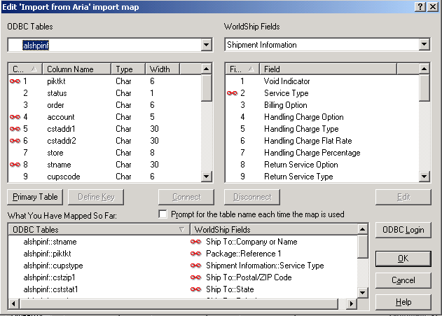

- Create an Export map:
The export map will associate each field in ARUPSHP file to its corresponding field in UPS.

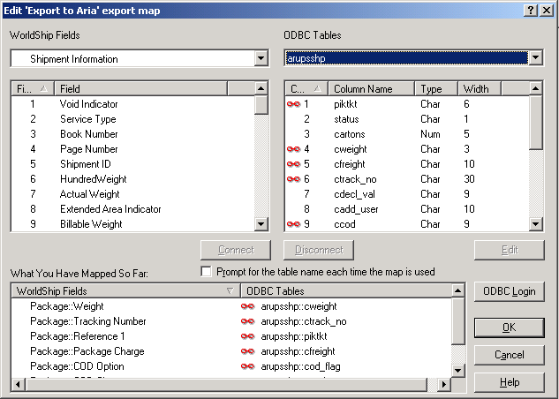
Importing shipments from Aria

There are two ways to import shipments (pick tickets) from Aria as follows:

- Keyed Import:
This option is located under “UPS ONLINE CONNECT” option.
This allows the user to specify the pick ticket # to be imported from Aria.

- Batch Import:
The user will run the batch import if he wants to import all the shipments updated in ALSHPINF file. Upon running the batch import, the imported shipments will show in the “Pick up” log screen under “Imported shipments” node.

Exporting shipments to Aria

There are two ways to export shipments to Aria as follows:

- Automatic Export after processing shipments:
If this option is enabled, the shipment will be automatically exported to Aria once it is processed through UPS. In other words, UPS will automatically create records for the processed shipments in ARUPSSHP file.

- Automatic Export during end of day:
If this option is enabled, the shipments processed during the day will be automatically exported to Aria upon doing the “End of day processing”

